QUERY 1:

OUTPUT:

QUERY 2:
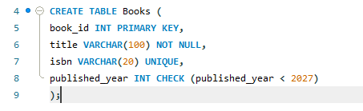
OUTPUT:

QUERY 3:
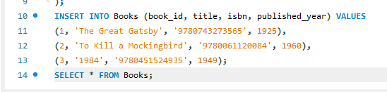
OUTPUT:

QUERY 4:
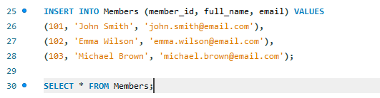
OUTPUT:

QUERY 5:
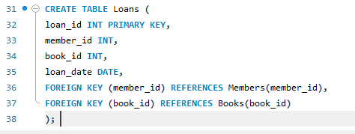
OUTPUT:

QUERY 6:
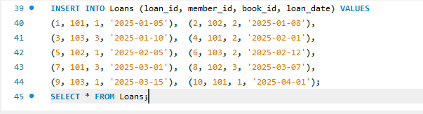
OUTPUT:

QUERY 7:
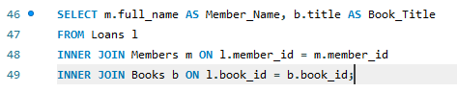
OUTPUT:

QUERY 8:
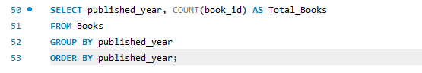
OUTPUT:
QUERY 9:
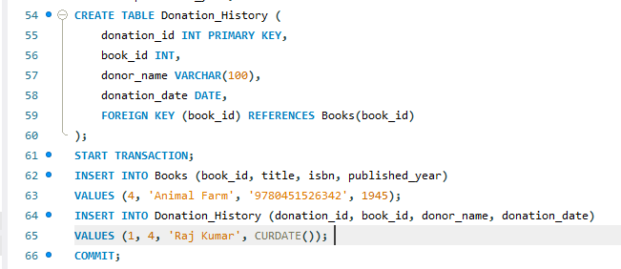
OUTPUT:

QUERY 10:


OUTPUT:

